**Assisted Practice: 4.1 Build a Custom Docker Image**

This section will guide you to**:**

* Build a custom Docker image using a custom Dockerfile and deploy it on Docker host.

Prerequisites:

* Docker must be installed on your system.

This lab has three subsections, namely**:**

4.1.1 Clone Git repository

4.1.2 Docker Build

4.1.3 Pushing the code to GitHub repositories

Docker is already installed in your lab. (Refer FSD: Lab Guide - Phase 5)

**Step 4.1.1:** Clone Git repository

* First, clone the Git repository on a Docker host using the command below:

git clone <https://github.com/Anuj1990/Docker.git>

**Step 4.1.2:** Docker Build

* Then, proceed with the docker build command to build a custom docker image.

cd Docker

dockerbuild -t phpcode . -f Dockerfile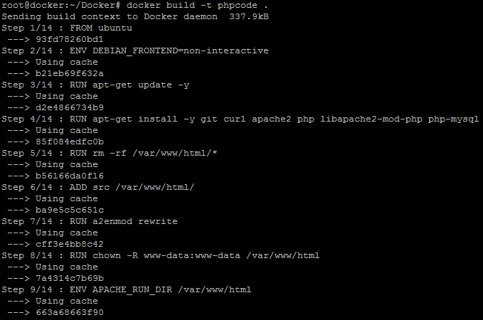

* Once the image is built, check the image using docker run command and then run it to initialize custom container on Docker host.

docker images

docker run -d --name phpcode -p 80:80 phpcode

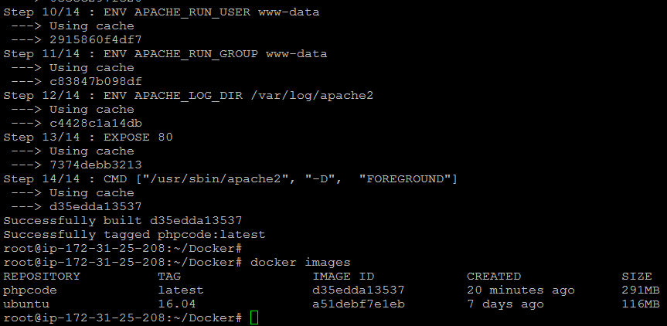

* Once the container is up and running, validate the connectivity using the **curl** command to see if **php code** is running on port 80 or not.

**Step 4.1.3:** Pushing the code to your GitHub repositories

* Open your command prompt and navigate to the folder where you have created your files.

**cd <folder path>**

* Initialize your repository using the following command:

**git init**

* Add all the files to your git repository using the following command:

**git add .**

* Commit the changes using the following command:

**git commit . -m “Changes have been committed.”**

* Push the files to the folder you initially created using the following command:

**git push -u origin master**